Ethical Hacking and Web Application Security Assignment
Unit I - Foundations of Ethical Hacking

Question 1
Define ethical hacking. Explain the difference between White Hat, Black Hat, and Grey Hat hackers with suitable examples.

Answer
Ethical hacking is the authorized and legal practice of testing computer systems, networks, and applications to discover security weaknesses before criminals can exploit them. An ethical hacker works only with written permission, follows an agreed scope, avoids unnecessary damage or data exposure, documents the findings, and recommends fixes. The purpose is to improve confidentiality, integrity, and availability of information systems.
Hackers are commonly classified by their authorization, intent, and method of disclosure.
Type | Authorization and intent | Typical activity | Suitable example
White Hat | Has explicit permission and works to improve security. | Performs a controlled assessment, reports weaknesses, and supports remediation. | A company hires a security consultant to test its online banking portal before release.
Black Hat | Acts without permission for malicious or personal gain. | Steals data, installs malware, disrupts services, or demands ransom. | An attacker breaks into an e-commerce database and sells customer card data.
Grey Hat | May access or test a system without permission, but may not intend direct harm. | Finds a flaw independently and may disclose it, sometimes after accessing the system beyond authorization. | A researcher discovers an exposed website admin panel without approval and informs the owner; the access was still unauthorized.
In summary, the key distinction is authorization. White Hat hackers are authorized defenders; Black Hat hackers are unauthorized attackers; and Grey Hat hackers may have helpful intentions but operate without formal permission. Only White Hat activity is appropriate for an ethical hacking engagement.

Question 2
Explain the CIA Triad in cybersecurity. How do Confidentiality, Integrity, and Availability apply to an organization's security?

Answer
The CIA Triad is a foundational cybersecurity model used to guide security decisions. It consists of Confidentiality, Integrity, and Availability. An organization must protect all three because a system can be insecure even if only one of them fails.
Principle | Meaning | Organizational application | Example control
Confidentiality | Information is available only to authorized people and systems. | The organization restricts access to customer records, employee data, financial documents, and passwords. | Role-based access control, multi-factor authentication, encryption, and least-privilege permissions.
Integrity | Information remains accurate, complete, and protected from unauthorized change. | The organization ensures that business records, software, transactions, and reports cannot be altered improperly. | Input validation, hashes, digital signatures, audit logs, and change-control procedures.
Availability | Authorized users can access systems and data when needed. | The organization keeps essential services such as websites, email, payment systems, and backups operational. | Backups, redundancy, disaster-recovery plans, monitoring, patching, and DDoS protection.
For example, in an online banking system, confidentiality protects account details from unauthorized viewing; integrity ensures that transfers and balances are not changed fraudulently; and availability ensures that customers can access the service when required. Security controls should be balanced across all three principles.

Question 3
Explain the five phases of ethical hacking: Reconnaissance, Scanning and Enumeration, Gaining Access, Maintaining Access, and Clearing Tracks.

Answer
An ethical hacking engagement follows a structured process. The activities must be authorized in writing, limited to the agreed scope, and documented so that the organization can fix the identified weaknesses.
Phase | Purpose and typical activity | Ethical-hacking requirement
1. Reconnaissance | Collect information about the target before direct interaction. This may include public domain details, technologies, employee-facing information, and the attack surface. | Use only approved sources and the agreed target scope. Record the sources and information gathered.
2. Scanning and Enumeration | Identify reachable hosts, open ports, services, versions, users, shares, and other exposed resources. | Use approved scanning tools and safe scan settings. Avoid disruption and retain scan evidence for the report.
3. Gaining Access | Validate a weakness by obtaining controlled access to a system, application, or account in the lab or authorized target. | Use the least intrusive proof possible. Do not access unnecessary personal data or expand beyond the written scope.
4. Maintaining Access | Assess whether an attacker could retain access after initial compromise, such as through a temporary test account or a permitted persistence simulation. | Only simulate persistence when explicitly authorized. Use reversible methods and remove all test artifacts afterward.
5. Clearing Tracks | In malicious activity this means hiding evidence. In ethical hacking, it means safely cleaning up test files, accounts, sessions, and configuration changes. | Do not conceal actions from the organization. Preserve audit evidence for reporting, restore the environment, and confirm cleanup with the owner.
The final outcome of all five phases is a clear report: what was tested, which weaknesses were validated, the business impact, evidence of the findings, and prioritized remediation steps. Ethical hackers must keep the target owner informed throughout the engagement.

Question 4
Explain the concept of vulnerability assessment and penetration testing (VAPT). Differentiate between vulnerability assessment and penetration testing.

Answer
Vulnerability Assessment and Penetration Testing (VAPT) is a combined security-testing approach used to identify, evaluate, validate, and help remediate weaknesses in systems, networks, and web applications. A vulnerability assessment identifies and prioritizes possible weaknesses. Penetration testing goes further by safely attempting to validate whether selected weaknesses can be exploited and what impact they could have.
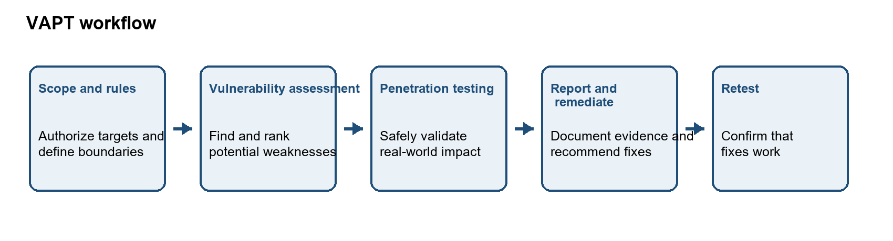
Figure 1. A typical authorized VAPT workflow.
Aspect | Vulnerability assessment | Penetration testing
Main purpose | Find and classify potential security weaknesses. | Safely validate selected weaknesses and determine their practical impact.
Depth | Broad coverage; often automated and repeated regularly. | Focused and deeper investigation of high-risk findings.
Typical tools | Vulnerability scanners, configuration checks, and asset inventories. | Controlled test tools, manual verification, proxy tools, and approved lab exploits.
Output | A list of possible vulnerabilities with severity and remediation guidance. | Evidence that a weakness was or was not exploitable, including impact and proof of concept.
Example | A scanner reports that a server may use outdated TLS settings. | A tester confirms in scope that the weak settings permit an insecure connection and documents the risk.
In practice, an organization should use both activities. Regular vulnerability assessments provide wide and continuous visibility, while periodic penetration tests demonstrate whether important weaknesses can lead to meaningful business impact. All testing must be authorized and performed within defined rules of engagement.

Question 5
What is passive reconnaissance? Explain how Google Dorking can be used to identify publicly available information about a target.

Answer
Passive reconnaissance is the collection of information about an organization from sources that are already publicly available, without directly probing or interacting with its systems. It helps an authorized security tester understand the visible attack surface while minimizing impact on the target. Typical sources include public websites, search engines, DNS records, WHOIS data, social-media posts, job advertisements, and documents published online.
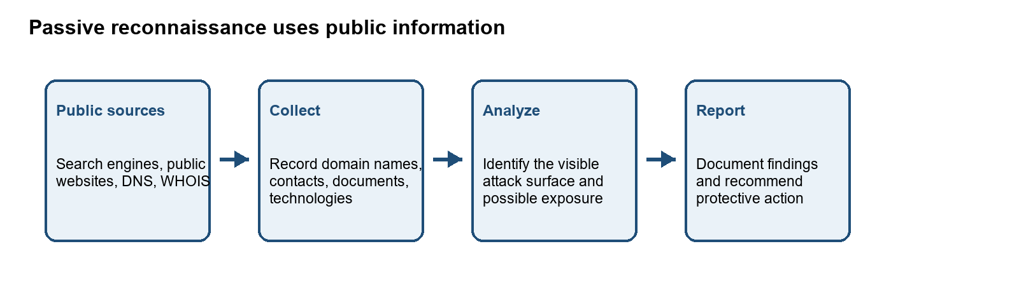
Figure 2. Passive reconnaissance workflow in an authorized assessment.
Google Dorking, also called Google hacking, uses advanced Google search operators to narrow results and locate information that has been indexed publicly. It does not grant access to private systems; it only reveals content that search engines can already find. In an authorized assessment, it can help identify exposed documents, public login pages, subdomains, technology references, and accidental information disclosure.
Search operator | Safe example | Possible authorized observation
site: | site:example.org | Lists indexed pages from a specific approved domain.
filetype: | site:example.org filetype:pdf | Finds publicly indexed PDF documents on the approved domain.
intitle: | site:example.org intitle:login | May locate publicly visible pages with a selected word in the title.
inurl: | site:example.org inurl:contact | May identify public URLs that contain a selected term.
Example: an authorized tester might search an approved organization domain for PDF files to check whether public documents unintentionally reveal software versions, internal email addresses, or outdated contact information. Any sensitive discovery should be documented responsibly and reported to the organization; the tester must not use it to access systems or accounts.

Question 6
Explain WHOIS, nslookup, and dig. What type of information can be obtained using each tool?

Answer
WHOIS, nslookup, and dig are information-gathering tools commonly used when examining domain registration and DNS. WHOIS queries registration data, while nslookup and dig query the Domain Name System (DNS), which maps domain names to records such as IP addresses and mail servers. The information returned depends on the domain registry, DNS configuration, and privacy protections in place.
Tool | What it queries | Information commonly returned | Example use
WHOIS | Domain registration databases and registrar/registry services. | Registrar, registration and expiry dates, domain status, name servers, and registrant details when those details are not redacted. | Check which name servers are associated with a domain and when its registration expires.
nslookup | DNS records using a DNS resolver. | A/AAAA address records, MX mail servers, NS name servers, and sometimes TXT or other records, depending on query and implementation. | Look up the IP address or mail server for a domain from a command prompt or terminal.
dig | DNS records using a DNS resolver, with detailed response information. | Requested record data, DNS response sections, TTL values, flags, and query timing; supports explicit record types such as A, MX, NS, and TXT. | Inspect a specific DNS record and the answer/authority sections returned by a resolver.
Example commands for a domain you are authorized to examine are shown below. Replace example.org with the domain in scope. WHOIS availability and output format can vary by operating system and registry.
whois example.org
nslookup example.org
nslookup -type=MX example.org
dig example.org A
dig example.org MX
For example, an MX lookup can show which mail servers receive email for a domain, while an A lookup returns an IPv4 address when one is published. These results describe public configuration; they do not prove that a host is vulnerable or that a service is reachable. Record the query and observation accurately, and perform any further testing only on authorized targets.

Question 7
Perform passive reconnaissance on an authorized domain using theHarvester, WHOIS, nslookup, and dig. Document the domains, subdomains, IP addresses, DNS records, mail servers, and other relevant information identified.

Answer
Passive reconnaissance collects information from public sources and DNS without attempting to exploit or gain access to the target. This practical exercise should be performed only on a domain that you own or have explicit permission to assess. The commands below use theHarvester's passive certificate sources and DNS lookup utilities. Replace YOUR_AUTHORIZED_DOMAIN with the exact domain approved for your exercise. The selected public providers receive the domain name as a query; review your lab rules before running them.

Procedure
1. Open the terminal in your Kali Linux virtual machine or another authorized lab system. Confirm that theHarvester, whois, nslookup, and dig are installed. Run theHarvester -h if you need to check its available options.
2. Replace YOUR_AUTHORIZED_DOMAIN in each command below with the approved domain, without adding https:// or a page path.
3. Run the commands one at a time. Save the command output or copy it into your notes. A result with no subdomains can be a valid observation; do not invent findings.
4. Compare DNS results from nslookup and dig. Record the resolver output, record types queried, and any relevant IP addresses or mail-server names.

Commands used
theHarvester -d YOUR_AUTHORIZED_DOMAIN -b crtsh,certspotter -f q7_recon
whois YOUR_AUTHORIZED_DOMAIN
nslookup YOUR_AUTHORIZED_DOMAIN
nslookup -type=MX YOUR_AUTHORIZED_DOMAIN
dig YOUR_AUTHORIZED_DOMAIN A
dig YOUR_AUTHORIZED_DOMAIN MX
dig YOUR_AUTHORIZED_DOMAIN NS
dig YOUR_AUTHORIZED_DOMAIN TXT
TheHarvester queries the selected public certificate sources and consolidates any domain or subdomain findings they return. WHOIS may show registrar, registration dates, status, and name-server information; registrant details may be privacy-protected. nslookup and dig query DNS. A and AAAA records can identify IPv4 and IPv6 addresses, MX records identify mail servers, NS records identify authoritative name servers, and TXT records may contain domain-verification or email-security policy text.

Results to record
Fill this table from your own command output. If a command returns no data, write 'No result returned' and include the relevant command in your evidence.
Information requested | Your observed result | Source / command
Authorized domain | Complete after the authorized run | Record command or source
Subdomains / hostnames | Complete after the authorized run | Record command or source
IP addresses (A / AAAA) | Complete after the authorized run | Record command or source
DNS records (NS / TXT / other) | Complete after the authorized run | Record command or source
Mail servers (MX) | Complete after the authorized run | Record command or source
WHOIS details (as publicly available) | Complete after the authorized run | Record command or source
Other relevant observations | Complete after the authorized run | Record command or source

Screenshot evidence
Capture screenshots of the terminal after the commands finish. Show the command and enough output to support the results table. Use one or more screenshots if needed; keep text readable and do not expose unrelated personal information or credentials. Save them as Q7_theHarvester.png and Q7_DNS_WHOIS.png. Insert them under this heading with captions that identify the command shown. The screenshots and results must come from your authorized run.
At present, the practical results and screenshots still need to be supplied from the authorized lab run.

Question 8
What is active reconnaissance? Explain how Nmap can be used to identify open ports, running services, service versions, and operating-system information.

Answer
Active reconnaissance gathers information by sending probes or requests directly to a target system. Unlike passive reconnaissance, it interacts with the target and may appear in its logs or trigger monitoring alerts. Network Mapper (Nmap) is a network discovery and security auditing tool that can test which ports respond and help identify the services available on an authorized host. It should be used only against systems included in written authorization or an isolated lab.
Nmap option / output | What it does | What the result tells the tester
Default scan / port and state | Checks commonly used TCP ports and classifies their response. | Open means a service is accepting connections; closed means reachable but no application is listening; filtered means a firewall or other filter prevents Nmap from deciding.
-sV | Probes discovered ports to identify the service protocol, application, and when possible its version. | Helps distinguish what is actually listening from a guess based only on the port number. A version may not always be identified.
-O | Uses TCP/IP stack fingerprinting to estimate the target operating system and device type. | Provides a best-match OS guess. Results can be uncertain, especially when the target or network filters responses.
PORT / SERVICE / VERSION columns | Summarize the port number and transport, observed state, likely service, and any detected product/version. | Provides a concise inventory of the network-facing services observed during the scan.
Example command for a deliberately vulnerable machine on an isolated lab network (replace the address with the actual IP of your authorized Metasploitable or other lab target):
nmap -sV -O 192.168.56.101
This command scans Nmap's commonly used TCP ports, attempts service/version identification, and requests OS detection. If it reports, for example, an open TCP port with a service name and version, that means the service responded to Nmap's probes; it does not by itself prove that the service is vulnerable. An OS result is an estimate, and Nmap may report that it could not determine the OS. Actual findings depend on the lab host and network, so record your own output if you perform the scan.
References: Nmap Reference Guide, Port Scanning Basics; Service and Version Detection; OS Detection. https://nmap.org/book/man-port-scanning-basics.html | https://nmap.org/book/man-version-detection.html | https://nmap.org/book/man-os-detection.html

Question 9
Perform an Nmap scan against an authorized lab target. Identify the open ports, services, service versions, and OS information. Present your findings in a structured table.

Answer
This practical scan was designed for an isolated, intentionally vulnerable lab machine such as Metasploitable or a host running DVWA. The target must be in the authorized lab scope. The command below uses Nmap service/version detection and OS detection and saves a normal-format output file for accurate reporting. Replace TARGET_IP with the actual IP address of your lab target.
1. Start the authorized target VM or lab application and locate its IP address from the lab console or instructor-provided network settings.
2. Open a terminal in the Kali Linux testing VM. Confirm that the Kali VM can reach the lab target on the isolated lab network.
3. Run the scan command below. Enter your sudo password only in the terminal prompt; do not include it in screenshots or the report.
4. Record the output exactly. Nmap may not identify every service version or OS, and filtered ports may not reveal whether a service is listening.
sudo nmap -sV -O -oN q9_nmap_results.txt TARGET_IP
Option notes: -sV probes discovered ports to identify services and versions; -O requests operating-system fingerprinting; -oN saves a readable report. The default scan checks Nmap's commonly used TCP ports. Use only the lab target IP, not a public or unrelated address.

Observed scan results
Complete this table from q9_nmap_results.txt. Keep one row for each port Nmap reports, and copy the service/version text accurately. The OS summary is reported separately because it applies to the host rather than an individual port.
Port / protocol | State | Service | Version / product | Observation
Complete from scan | Complete from scan | Complete from scan | Complete from scan | Add relevant note
Complete from scan | Complete from scan | Complete from scan | Complete from scan | Add relevant note
Complete from scan | Complete from scan | Complete from scan | Complete from scan | Add relevant note
Complete from scan | Complete from scan | Complete from scan | Complete from scan | Add relevant note
Complete from scan | Complete from scan | Complete from scan | Complete from scan | Add relevant note
Target IP: Complete from lab configuration.
OS information: Copy Nmap's OS guess and confidence wording, or state 'OS detection inconclusive' if Nmap could not identify it.
Tool and command: Nmap; sudo nmap -sV -O -oN q9_nmap_results.txt TARGET_IP.
Observation: Open ports show services that responded during this scan. A service/version result is an identification, not proof of a vulnerability. Filtered ports indicate that Nmap could not determine the port's state due to filtering.

Screenshot evidence
Capture a readable screenshot of the terminal showing the Nmap command and results, including the PORT, STATE, SERVICE, and VERSION lines and the OS summary if available. If the output does not fit on one screen, take more than one screenshot. You can reopen the saved result with 'cat q9_nmap_results.txt' or 'less q9_nmap_results.txt'. Save the image as Q9_Nmap_Scan.png and insert it below this heading. Do not include unrelated network addresses or credentials.
Actual target findings and screenshot evidence must be added from the authorized lab scan before submission.

Question 10
Explain the Metasploit Framework architecture. Describe the purpose of exploits, payloads, encoders, auxiliary modules, and post-exploitation modules.

Answer
The Metasploit Framework is an extensible penetration-testing platform. Its console and framework libraries let an authorized tester select modules, configure their options, run controlled checks, and manage results or sessions. Modules are distinct components that perform particular tasks. A typical authorized validation flow pairs an exploit module with a compatible payload, while auxiliary modules can gather or verify information and post modules can perform approved checks after a test session is established.
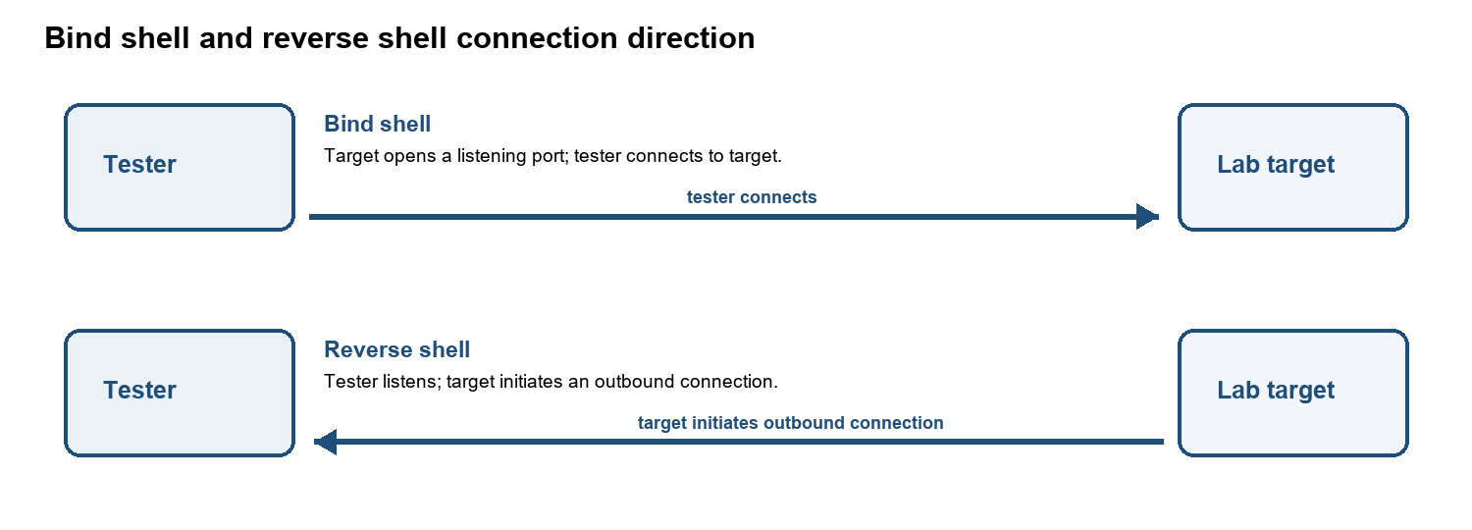
Figure 3. Simplified Metasploit module architecture and test flow.
Component | Purpose | Role in an authorized assessment
Exploit module | Implements a method for testing or taking advantage of a particular vulnerability or misconfiguration. | Used only against an in-scope lab target to validate a known weakness, with approval and safeguards.
Payload | Specifies the action or code that runs if an exploit succeeds, such as opening a controlled session. | Chosen to match the target platform and test objective. Payload selection is separate from the exploit itself.
Encoder | Transforms payload bytes to meet constraints such as avoiding characters that would break delivery or fit a required format. | May help with technical compatibility. Encoding does not guarantee antivirus or security-control evasion.
Auxiliary module | Performs supporting tasks such as information gathering, service checks, or other operations that do not use an exploit payload. | Can help assess or verify a service without establishing a shell/session.
Post-exploitation module | Runs approved checks through an established session to gather system information or validate security impact. | Used only within the authorized objective; minimize access to sensitive data and clean up test artifacts.
Metasploit modules do not make a test authorized by themselves. The tester must obtain permission, follow the agreed scope, use a lab or approved target, and document the selected tools, actions, results, and cleanup.
Reference: Rapid7 Metasploit Documentation, Getting Started - Metasploit Architecture. https://docs.rapid7.com/metasploit/getting-started/

Question 11
Explain the difference between bind shell and reverse shell. Discuss situations in which each type of shell may be used in a controlled penetration-testing environment.

Answer
A shell is a command-line interface that can provide interactive access to a computer. In a controlled penetration test, bind and reverse shells describe which side initiates the network connection. They are assessed only in a lab or on an explicitly authorized target, because a shell can allow commands to run with the permissions of the affected process.
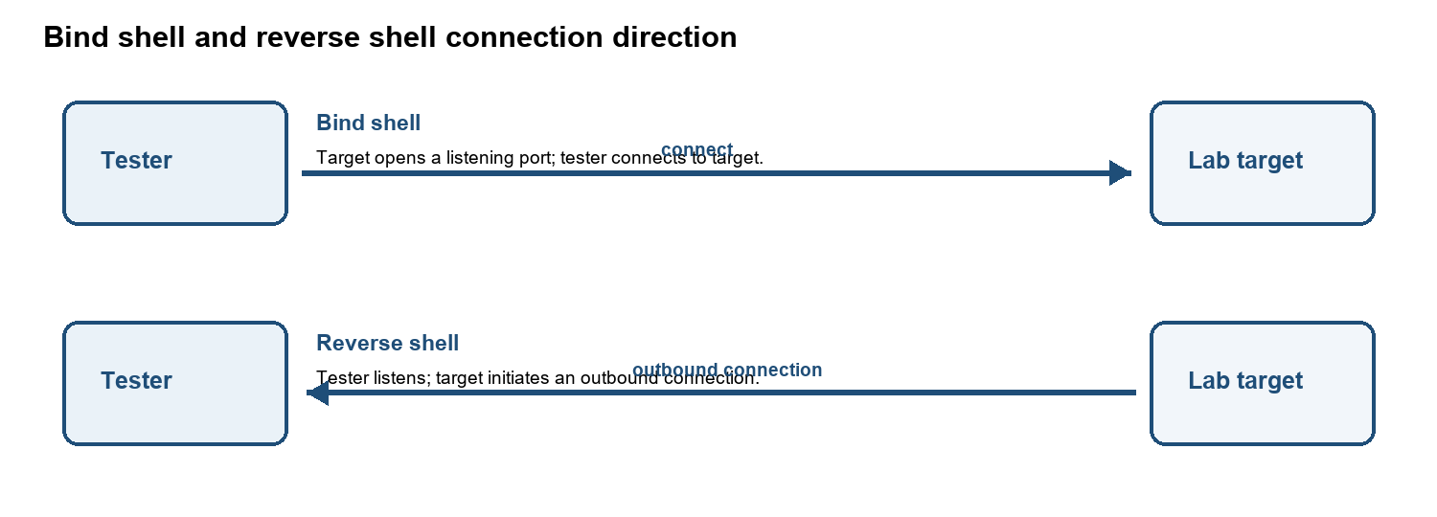
Figure 4. The connection initiator differs between bind and reverse shells.
Type | Connection behavior | When it may be considered in a lab | Limitations
Bind shell | The target listens on a port and the tester connects to it. | Useful when the test network permits an inbound connection to the lab host and the listening service can be observed safely. | Host or network firewalls often block inbound connections; the listening port may expose the service to other hosts.
Reverse shell | The tester listens and the target initiates an outbound connection back to the tester. | Useful in an isolated lab when inbound connections to the target are blocked but a permitted outbound route exists. | Egress filtering can block the connection; the listener address and routing must be correct, and monitoring may alert.
Both types create an interactive session and therefore carry risk. A tester should agree on the permitted payload, callback direction, ports, time window, and cleanup plan before testing. For many assessments, a non-interactive proof or scanner result is safer than opening a shell.

Question 12
What is privilege escalation? Explain the difference between vertical and horizontal privilege escalation with suitable examples.

Answer
Privilege escalation occurs when a user or process obtains permissions beyond those properly assigned to it. It can result from software flaws, excessive permissions, weak access-control checks, exposed credentials, or incorrect system configuration.
Type | Change in access | Example | Security impact
Vertical privilege escalation | A user gains a higher privilege level or role. | A standard employee account can access an administrator-only settings page or run an administrative action. | Can enable system configuration changes, broader data access, or control over other accounts.
Horizontal privilege escalation | A user accesses another account's data or actions at the same privilege level. | A customer changes an account identifier in a request and views another customer's order history. | Can expose or modify another user's records without granting administrator rights.
Applications should enforce authorization on the server for every sensitive action and data object. They should deny access by default, verify ownership or role for each request, apply least privilege, and log denied access attempts. Changing a button or URL in the browser should never be enough to grant permission.

Question 13
Explain persistence in post-exploitation. Discuss common persistence concepts and why persistence should be detected and removed during incident response.

Answer
Persistence is an attacker's ability to regain access after an initial compromise, including after a user logs out or a system restarts. During an authorized assessment, persistence is simulated only when the rules of engagement explicitly allow it. Incident responders treat unexpected persistence as evidence that an intruder may still control an account or system.
Persistence concept | What defenders may check | Response consideration
Unrecognized accounts, keys, or tokens | Review local and cloud account changes, SSH authorized keys, API tokens, and authentication logs. | Preserve evidence, disable unauthorized identities, rotate secrets, and revoke active sessions or tokens.
Startup entries, scheduled tasks, or services | Compare autorun items, scheduled jobs, services, and system configuration against a known-good baseline. | Determine origin and scope before removal; remove unauthorized entries and close the weakness used to add them.
Web shells or modified application files | Check web roots, file integrity alerts, unexpected scripts, deployment history, and server logs. | Isolate the host as needed, preserve a forensic copy, remove malicious files, and restore verified code.
Cloud or identity-provider persistence | Audit new app registrations, federated credentials, role grants, mailbox rules, and unfamiliar login sessions. | Revoke suspicious grants and sessions, rotate credentials, and review linked systems for further access.
Persistence must be investigated because simply deleting the first visible file may leave another access route in place. Responders should contain the incident, preserve logs and evidence, identify all affected accounts and systems, remove unauthorized access mechanisms, remediate the original entry point, and verify the environment before returning it to service. Reimaging may be appropriate when system integrity cannot be trusted.

Question 14
Explain the OWASP Top 10. Describe any five vulnerabilities from the OWASP Top 10 and provide a brief example of each.

Answer
The OWASP Top 10 is an awareness document that summarizes major categories of web application security risk. OWASP's current released edition is the 2025 list. It supports security education and prioritization; it is not a complete checklist or a substitute for testing a particular application.
ID | OWASP Top 10:2025 category
A01 | Broken Access Control
A02 | Security Misconfiguration
A03 | Software Supply Chain Failures
A04 | Cryptographic Failures
A05 | Injection
A06 | Insecure Design
A07 | Authentication Failures
A08 | Software or Data Integrity Failures
A09 | Security Logging and Alerting Failures
A10 | Mishandling of Exceptional Conditions

Five categories with examples
Category | Explanation | Brief example
A01 Broken Access Control | The application fails to enforce what a logged-in user is allowed to view or change. | A customer edits an order ID in a URL and sees another customer's order.
A02 Security Misconfiguration | A system or application uses unsafe settings, unnecessary features, or default credentials. | A production server exposes a sample admin page with its default password still enabled.
A03 Software Supply Chain Failures | A weakness or compromise in dependencies, build tools, update channels, or software distribution affects the application. | A project includes an unmaintained vulnerable library and does not inventory or update it.
A05 Injection | Untrusted input is interpreted as part of a command or query instead of as data. | An application concatenates a search field into SQL, allowing crafted input to change the query.
A07 Authentication Failures | Weak identity verification or session handling lets an attacker impersonate a user. | A login has no effective rate limit, allowing repeated guesses against a weak password.
These examples are illustrative. The correct category for a real finding depends on the root cause and the OWASP edition being used. A single application issue can relate to more than one risk category.
Reference: OWASP Top 10:2025, official list and category descriptions. https://top10.owasp.org/2025/

Question 15
Using DVWA, demonstrate a Brute Force vulnerability using Hydra in an authorized lab environment. Explain the vulnerability, observations, and security controls that can prevent brute-force attacks.

Answer
A brute-force weakness exists when an application allows repeated login attempts without effective controls, making it easier to guess a password. Hydra can automate a small, controlled test against the DVWA Brute Force page, but the exact HTTP form parameters, session cookie, and failure message depend on the DVWA setup. The practical evidence and observations below must come from your own local DVWA lab; no real account or public target should be tested.

Lab procedure to complete later
1. Start DVWA on your isolated lab VM and sign in with a disposable lab account. Set DVWA Security to Low only for this demonstration.
2. Open the Brute Force page and verify a normal failed login by hand. Note the request path, form fields, session cookie, and exact failure message using the browser or Burp Suite.
3. Use a tiny test-only password list containing a few values, including the disposable lab account's known password. Configure Hydra for only the DVWA lab IP, one username, one request at a time, and a short timeout. Stop after the expected result.
4. Record whether repeated attempts were accepted, whether Hydra identified the test credential, and what message appeared. Restore DVWA's security setting and remove the temporary wordlist after the exercise.
Hydra command structure (not ready to run until the DVWA request path, fields, session cookie, and failure text are filled from your lab):
hydra -l TEST_USER -P q15-small.txt DVWA_LAB_IP http-post-form "PATH:FORM_FIELDS:F=FAILURE_TEXT" -t 1 -W 2
The response string and cookie syntax must match the request observed in your DVWA instance; do not guess these values. When you are ready to run it, I can help you build the exact lab-only command from your captured request.
What to record | Your lab observation
DVWA URL / lab IP | Complete from your local lab
Tool and bounded command | Hydra; complete from the captured DVWA request
Observed behavior and result | Complete after the authorized run
Evidence screenshot | Add screenshot of the local DVWA result and terminal output

Controls
Prevent brute-force attacks with rate limiting, progressive delays, temporary lockout or risk-based challenges, multi-factor authentication, password screening against compromised passwords, safe password hashing, monitoring and alerting for repeated failures, and secure account recovery. Controls should avoid creating a simple denial-of-service path through permanent account lockout.
Evidence still required: a readable screenshot of the DVWA Brute Force page or result and the limited Hydra run in your authorized lab. Add the real observation and screenshot here before submission.

Question 16
Using DVWA and Burp Suite, demonstrate how an intercepted HTTP request can be analyzed and modified. Explain the purpose of Proxy, Repeater, and Intruder in Burp Suite.

Answer
Burp Suite is an intercepting web proxy that lets a tester inspect HTTP requests and responses sent by a configured browser. In the local DVWA exercise, the tester can pause a request, review its method, URL, headers, cookies, and parameters, then change a harmless test value and forward it. This demonstrates how client-supplied values can be changed and why the server must validate and authorize every request.
Burp tool | Purpose in the exercise
Proxy | Intercepts and displays browser-to-application HTTP traffic; the tester can inspect, edit, forward, or drop a request.
Repeater | Sends a selected request again after manual edits, so responses can be compared one change at a time.
Intruder | Automates repeated requests with controlled payload positions for authorized testing. Use only a small test set against local DVWA.

Lab procedure to complete later
1. Start local DVWA and Burp Suite. Configure a browser profile to use Burp's local proxy and trust Burp's CA certificate only in that lab browser profile if HTTPS inspection is needed.
2. In Burp Proxy, enable interception and submit a harmless DVWA form value. Inspect the request line, method, parameters, headers, and cookie. Forward it to the local DVWA instance.
3. Send the request to Repeater, change one ordinary test parameter, resend it, and compare the response with the original.
4. If demonstrating Intruder, select a single parameter and use only a few benign values against DVWA. Avoid broad wordlists or any non-lab host.
What to record | Your lab observation
Request analyzed | Record method, endpoint, and the harmless parameter changed
Response comparison | Complete after comparing original and modified requests
Tools used | Burp Proxy, Repeater, and optionally Intruder
Evidence screenshot | Add local Proxy request and Repeater response screenshots
Evidence still required: screenshots from the local browser/Burp session showing the intercepted request and the modified request/response. Redact session cookies before sharing screenshots or submitting them.

Question 17
Using DVWA, investigate SQL Injection. Explain how user input can affect a database query, identify the vulnerability, and discuss appropriate mitigation techniques such as parameterized queries.

Answer
SQL Injection occurs when an application builds a database query by joining untrusted input into SQL text. The database may then interpret part of the input as SQL syntax, changing the query's meaning. In DVWA's isolated SQL Injection exercise, compare a normal numeric ID lookup with a controlled test input and observe whether the returned sample records change unexpectedly.

Lab procedure to complete later
1. Start local DVWA and select the SQL Injection page. Set DVWA Security to Low for the demonstration and use only the built-in sample data.
2. Submit a normal ID such as 1 and record the returned sample user. Then use the lab exercise's controlled input, for example 1' OR '1'='1' #, and observe whether the result set changes. SQL comment syntax can depend on the database, so record the exact input and response.
3. Identify the issue as SQL Injection if input changes query logic and returns records beyond the intended lookup. Do not modify or delete data.
Evidence item | Your observation
Normal input and response | Complete from the local DVWA page
Controlled test input and response | Complete from the local DVWA page
Root cause | Untrusted input was interpreted as part of SQL, if confirmed
Screenshot | Add screenshots showing baseline and controlled result

Mitigation
Use parameterized queries or prepared statements so SQL code and user data remain separate. Apply server-side input validation as an additional control, use database accounts with only the permissions the application needs, avoid exposing database errors to users, and log suspicious input safely. Input filtering alone is not a substitute for parameterized queries.
Evidence still required: screenshots of the baseline and controlled test results from local DVWA. Record only the sample data shown by the lab.

Question 18
Using DVWA, investigate OS Command Injection. Demonstrate the issue using a harmless command in the isolated lab and explain the root cause, impact, and mitigation.

Answer
OS Command Injection occurs when an application inserts untrusted input into an operating-system command in a way that lets the input change the command or add another command. The impact depends on the privileges of the application process and can range from unintended output to execution of commands on the server. Demonstrate only in isolated local DVWA, using a harmless identity command and no filesystem changes.

Lab procedure to complete later
1. Start local DVWA on an isolated lab VM and open the Command Injection page. Set DVWA Security to Low for the demonstration.
2. Submit the normal loopback address 127.0.0.1 and record the baseline ping output.
3. In the local DVWA input only, append a harmless command such as 127.0.0.1 && whoami. If the lab's operating system or shell uses different syntax, follow your instructor's lab guidance. Do not use commands that read files, change settings, download content, or contact external hosts.
4. Compare the response. If the web server's account name appears after the ping output, the user input was interpreted as an additional shell command. Record the output and clean up any test artifacts (this example creates none).
Finding detail | Your lab observation
Baseline command input | 127.0.0.1; record returned ping output
Harmless test input | Record the exact local test input used
Observed result and impact | Record whether command output was appended and the application context
Screenshot | Add local DVWA baseline and controlled result screenshots

Mitigation
Prefer a safe library or built-in API instead of invoking a shell. If a process must be run, pass the executable and arguments separately without shell interpretation, allowlist valid input, validate each argument, run the application with least privilege, and avoid returning raw command output to users. Central logging and monitoring can help detect unexpected command behavior.
Evidence still required: screenshots of the local DVWA baseline and harmless command result. Keep the command and output readable and do not include unrelated system details.

Question 19
Explain Cross-Site Scripting (XSS) and its types: Reflected XSS, Stored XSS, and DOM-based XSS. Also explain how input validation and output encoding help prevent XSS.

Answer
Cross-Site Scripting (XSS) is a web vulnerability in which untrusted content is interpreted by a browser as executable script in a site's origin. This can let an attacker perform actions in a victim's browser or access data available to that page, depending on the application and browser controls. The three common types describe where the unsafe content comes from and how it reaches a browser execution context.
Type | How it happens | Brief example
Reflected XSS | A request value is immediately included in the response without safe context-specific encoding. | A search page displays a query string as HTML, so crafted input is interpreted by the browser instead of shown as text.
Stored XSS | Untrusted content is saved by the application and later displayed unsafely to one or more users. | A comment containing markup is stored and runs when another user opens the comment page.
DOM-based XSS | Client-side JavaScript reads untrusted data and sends it to a DOM sink that interprets it as HTML or script. | A page reads a URL fragment and assigns it to innerHTML, causing attacker-controlled markup to be parsed.

Prevention
Input validation checks that data matches the expected format, length, and allowed values for the field. It reduces unexpected input but cannot replace output encoding because valid text may still contain characters that have special meaning in HTML or JavaScript.
Output encoding converts data for the exact context where it is displayed so the browser treats it as text rather than code. Use framework-provided encoding for HTML, quoted attributes, JavaScript strings, and URLs as appropriate. For DOM updates, prefer safe text APIs such as textContent over HTML-parsing sinks. If users are allowed to author limited HTML, use a well-maintained sanitizer with a restrictive policy. Content Security Policy is an additional layer, not a substitute for safe encoding.
Reference: OWASP Cross Site Scripting Prevention Cheat Sheet. https://cheatsheetseries.owasp.org/cheatsheets/Cross_Site_Scripting_Prevention_Cheat_Sheet.html

